EAGLE ACADEMY
COURSE SYLLABUS
Teacher: Ms. M. Roland, M.Ed. Course: Physics / Lab
Room: 413
School Email Address: mroland@nps.k12.nj.us Cell: (908) 619-7091

Course Description
Students at the high school level will continue to develop their science and engineering skills while focusing on several core themes in physics: motion, energy, momentum & collisions, gravity, and waves along with their applications in technologies for information transfer. Students will explore and investigate scientific phenomena while consistently applying math and ELA standards. Teacher instruction should focus on scaffolding students ability to use science and engineering practices and crosscutting concepts to meet the performance expectations. Each unit will have a capstone performance task where students will demonstrate their understanding of key concepts by incorporating the science and engineering practices, cross cutting concepts, and disciplinary core ideas into one standardized task.

The first unit focuses on motion and forces, and on how we can use scientific principles to measure and predict that motion. Performance expectations are centered on Newton’s Second Law. Students will use the content they learned to solve an engineering problem in the form of a performance task. The second unit focuses on conservation of energy and the application of that in real world context. Unit three brings together previous learning experiences from the first and second unit while having students investigate real world phenomena such as car crashes. Students will apply the conservation of momentum and energy to create a model of how to make collisions safer for humans. The fourth unit focuses on how objects are able to move in our solar system, with Newton’s law of gravitation and Kepler's laws as a basis for creating a model of how the solar system and universe function. Forces involved with electricity and magnetism are also explored. The unit culminates with a performance task where students investigate and discuss claims about an accident on the International Space Station. In the fifth and final unit students study waves and their structure as well as investigate how energy in the form of electromagnetic radiation makes modern communication possible.

Obligatory Supplies Needed
It is essential that your child be prepared to learn daily. Research has proven that students who have obtained and use the necessary educational supplies are far more successful than their peers who are unprepared to learn. If you are having difficulty obtaining these supplies, please let me know as soon as possible. I will do everything I can to ensure that your child has the required supplies to be successful in class. You may choose to obtain the supplies on your own, and I encourage you to do so. However, these supplies are obligatory. The supply list has been hyperlinked to the item at Walmart. These items can easily be ordered. The supplies are a part of your child’s grade.
- 2 Inch View Binder
- 5-Tab Dividers
- Lined Paper
- Package of Mechanical Pencils
- Highlighters
- 3 Pocket Folders
- Package of Dry Erase Markers
- 1 Texas Instrument Scientific Calculator

The Total Cost is $27.67 (with current sale prices). If you are unable to obtain the supplies, please have your child bring $30 to school and I will purchase the necessary materials.

Eagle Academy students should NOT attend class empty handed. Supplies are due by Monday, September 18, 2023. This assignment is a test grade.
Requirements
In my class, I do not have expectations. I have requirements.
Students are expected to arrive to class promptly with their obligatory supplies. During class, students are expected to participate and show proper respect to their teacher, classmates, and classroom. Students will be required to follow all rules and procedures that they are given by the teacher and the Newark Public Schools Code of Conduct.
It is mandatory that students use a two-ring binder, as there will be numerous documents which will need to be kept in an organized manner. These include handouts, lab reports, homework assignments, and graded tests and quizzes. This will be important throughout the year but will be especially important in preparing for the midterm and final exams.
Students will be given homework and reading assignments. These assignments need to be completed by the designated time.
Coursework and Assessment
Students will be assessed based on their results on mandatory homework assignments, class cooperation and participation, quizzes, tests, lab work and lab reports.
Tests will occur at the end of each major topic and are based on about 100 points.
Quizzes will have a point value of up to 50 points and may be given at any time, with or without prior notice.
Retakes of quizzes, tests, and lab work will be granted once the student provides sufficient evidence that he is prepared. The highest grade earned replaces the lower grade. Retakes are not given during class time. Arrange an appropriate time for retakes with your teacher.
Students will be conducting a full‐scale physics lab.
The District uses three grade scales: Default, Honors, and AP. The Honors grade scale offers
greater grade point values than the Default scale, and the AP scale is greater than the Honors
scale. The sum of grade points for all of the courses a student has taken is used to compute a
student’s GPA. Because of the greater value of the grade points, students taking Honors or AP
courses will have a higher GPA than students earning the same grades in a general Default grade
scale course. The grade points for a D or F are the same across all grade scales. The grade points
associated with each grade are shown by clicking here.

Grades
70% Summative Assessment (Exams, Tests, Unit Quizzes, Labs, Projects)
30% Formative Assessment (Homework, Simple Quizzes, Enter/Exit Questions, Weekly Rubric Score, Classwork, Participation)

Daily / Weekly Rubric Points
Every day a student is present, he will receive a possible fifteen points for class participation. Class Participation is a hefty part of a student’s overall grade.
2 Points
- A student must be present in class to receive their points. If you have an excused absence, you will receive all fifteen points. If the absence is unexcused, the student will lose his possible daily rubric points.
2 Points
- A student must be on time for class. This means you have entered class appropriately, signed-in, and started the DO NOW activity.
2 Points
- All students must have their obligatory supplies and any other additional materials. This includes the student’s obligatory binder.
1 Point
- Students must have a writing utensil. This should be included in the obligatory supplies.
3 Points
- Every student must remove his jacket and be in the appropriate clothing BEFORE entering class. He must wear the uniform properly. Young men are to remove all headphones, earbuds, hats, and wave caps. Shirts are to be tucked into the pants. Students are to be wearing their face masks.
3 Points
- Electronic devices must be placed in the zip pouches located on the desks. Students are to place their electronic devices in the pouch BEFORE the ringing of the bell. These devices are to remain in the pouch until the teacher grants permission to remove the devices.
2 Points
- Students are to enter class appropriately and with a smile. No attitudes beyond the classroom door.

Standard Operating Procedures
- Students are to arrive BEFORE the ringing of the bell.
- BEFORE they enter the room:
    - Electrical equipment, cell phones, earphones, earbuds and such other should not be visible and these items must be turned off. There is a clear bin on each table. Students are responsible for placing their electronics in the bin. This is a requirement,
    - Coats, hoodies, sweaters, jackets, headwear, baseball caps and wave caps should be removed prior to entering class.
    - Students should enter wearing the appropriate uniform with the shirts correctly tucked into the pants. Black belts, black shoes and appropriate ties.
    - Students should have their obligatory supplies. Do not request to “run to your locker.” Class is only for a brief period. The teacher will not waste that time by allowing students to consistently run to their lockers.
- Prior to entering the room, students will form a line outside the classroom door. The teacher will grade each student on their readiness to learn (uniform, materials, electronic devices). Attendance will be taken at this time and the entrance activity will be given.
- Some homework is for a student to practice outside of the classroom setting. Most of the assignments will be assigned as a graded activity. These assignments will be collected as students enter the room. Late assignments are to be placed in the appropriate basket.
- If there is an area of concern, or if the student wants to notify the teacher about anything, he is to complete the appropriate form and place it in the locked red mailbox. Ms. Roland will make sure she contacts the student by the end of the day.
- Students should be in their assigned seats, with their electronic equipment in the appropriate clear bin, starting the DO NOW Activity BEFORE the ringing of the bell.
- Please DO NOT:
    - Request a pass to your locker
    - Request a pass to the bathroom
    - Request a pass to the nurse or any other staff member
    - Socialize with your peers
    - Use the small window of time inappropriately
- As a class, the DO NOW Activity may be reviewed. It may be collected for a grade, or it may be used as an opportunity for students to share their work.
- Homework may be reviewed, collected or students may be asked for any questions. The class will then move on to the introduction of the lesson.
- After the introduction and/or preparatory set, students will be instructed on how to perform the inquiry, individual or group part of the lesson.
- The teacher will guide the lesson. Be sure to follow instructions.
- Towards the end of the class, the teacher will lead the class in the Demonstration of Learning or Exit Ticket. Students will either place this assignment in the appropriate basket or it will be collected.
- The teacher will share the homework assignment.
- DO NOT start to pack up without prior permission from the teacher. This is considered a waste of time. A time frame that will have to be made up before or after school.
- Please remember to stay in your lane, follow instructions, and behave in an adult manner.
- Students who choose to waste time will be required to make up the time before or after school.

Calculation of Final Grade and High School Requirements
Marking Period One: 20%
Marking Period Two: 20%
Midterm Assessment: 10%
Marking Period Three: 20%
Marking Period Four: 20%
Final Exam: 10%
Total: 100%

Language Arts and Literacy 20 Credits
Mathematics 20 Credits
Science 20 Credits
Social Studies 15 Credits
Financial Literacy 5 Credits
World Language 10 Credits
Visual and Performing Arts 5 Credits
Health, Safety, and Physical Education 20 Credits
21st Century Life and Career or Career and Technical 5 Credits
Electives 10 Credits
Total: 130 Credits

Note: To be eligible for sophomore status (10th grade), students must have earned 32.5 credits. To be eligible for junior status (11th grade), students must have earned 65 credits. To be eligible for senior status (12th grade), students must have earned 97.5 credits.

The following MUST all be completed to receive a diploma –
- Senior Thesis;
- Demonstrated proficiency on State Assessments;
- 80 hours of Community Service;
- FAFSA/NJAFAA
Comprehension and Signature on Contracts
Students and their parents / guardians are to read and comprehend the following forms and contracts. These documents can be read within Google Classroom. Once these documents have been read, families are to complete, sign, and submit the Student Information form and the Course Syllabus. These documents will be counted as a test grade. Completion and submission of these documents must be done by the following school day. Any questions and/or concerns, please contact Ms. Roland at the referenced cell phone number or email address. All materials have been linked and can be found by using these QR Codes.
No Bullying Contract
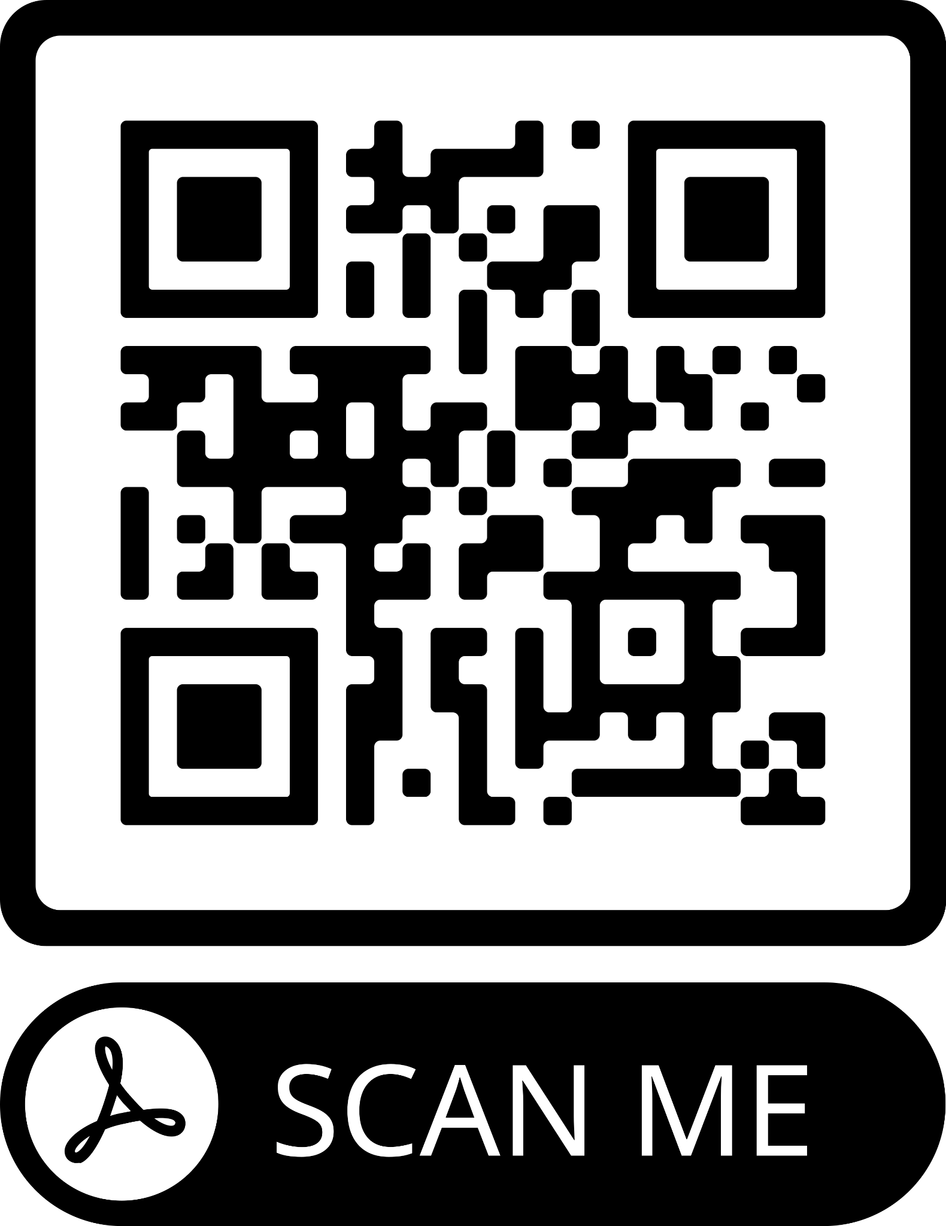

Cell Phone Contract

Educational Contract
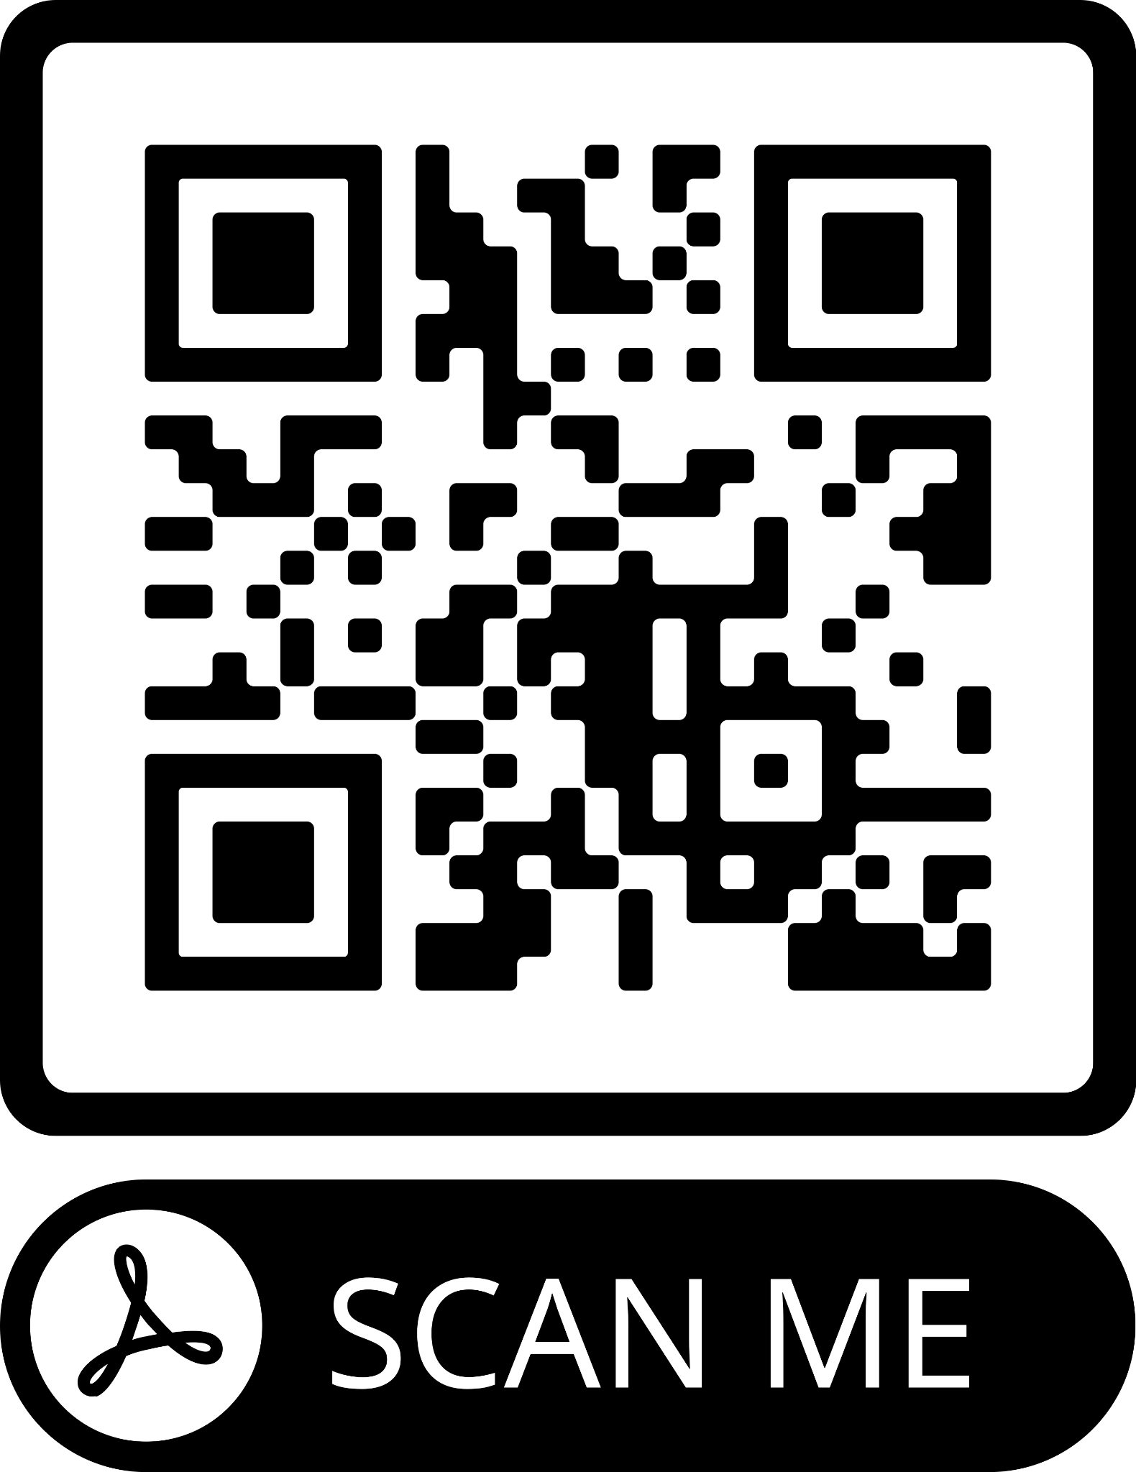

Fair Fighting

Internet Use

Media Release
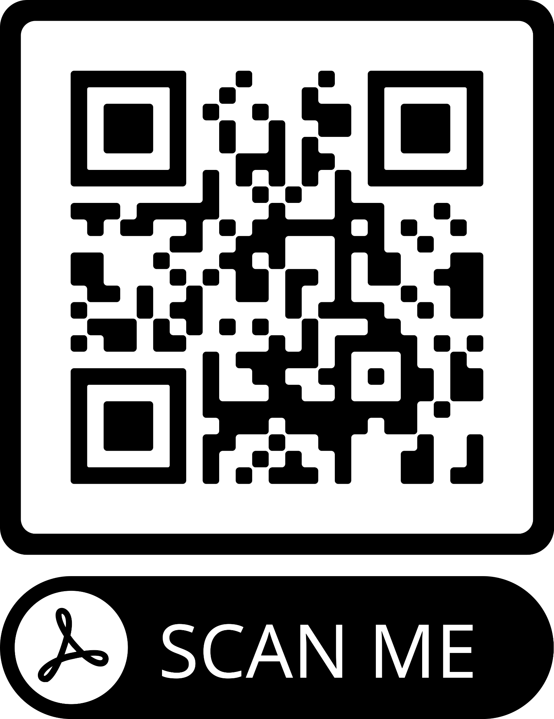

Teacher Contact Information
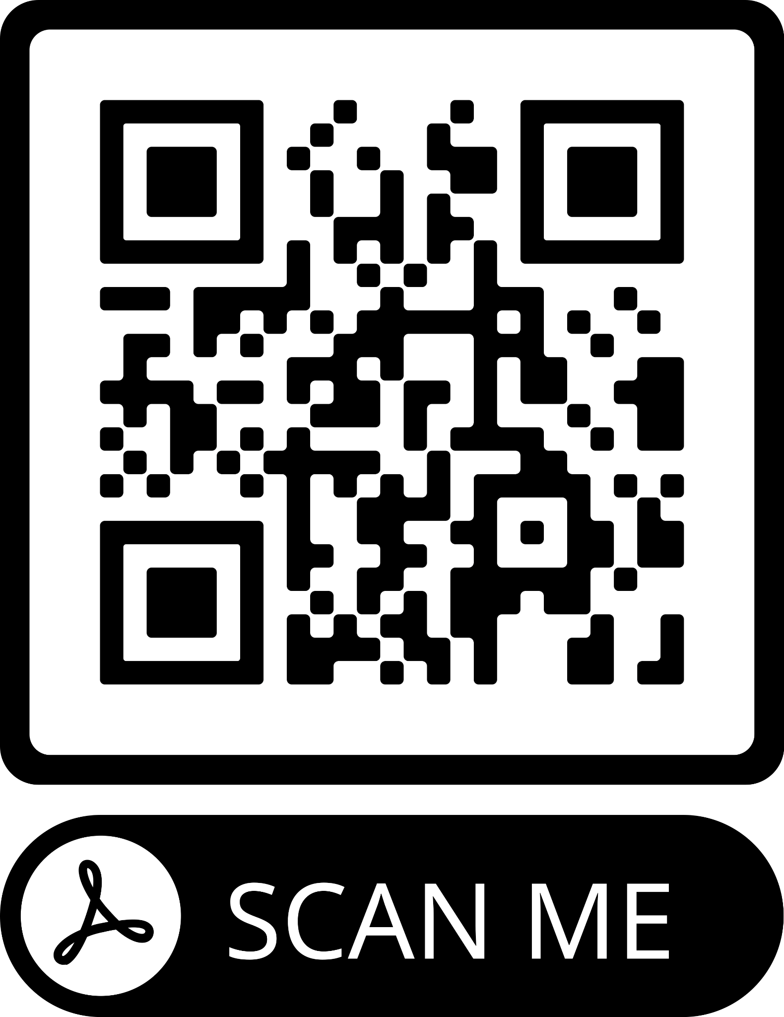

Student / Teacher Contract
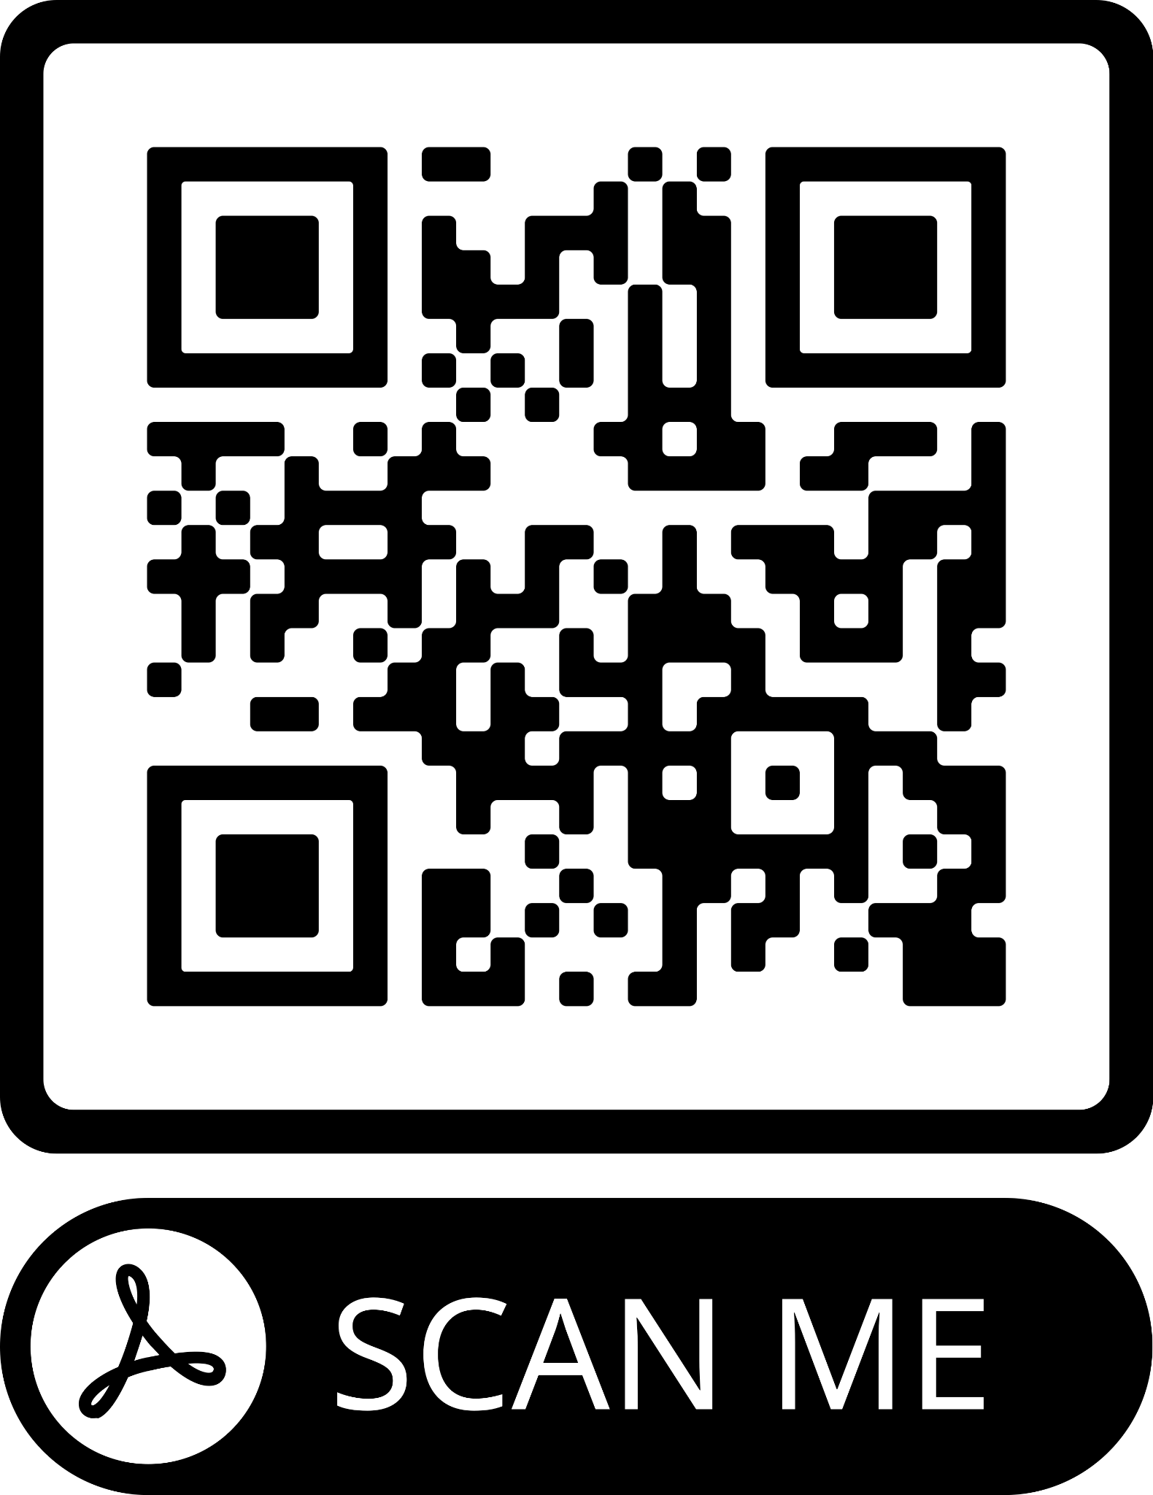

*****IMPORTANT*****
Lunch Application
Please remember to complete the Parent Google Form!

